1.Write a hive query to find the city wise list all the Condos which is not less than ten thousand.

For this query we will use the table created for the previous assignment and to fetch the required data we have used the hive. We have used distinct keyword to get the non repeated data of the city with the condition on the type condos and the price in the where clause.

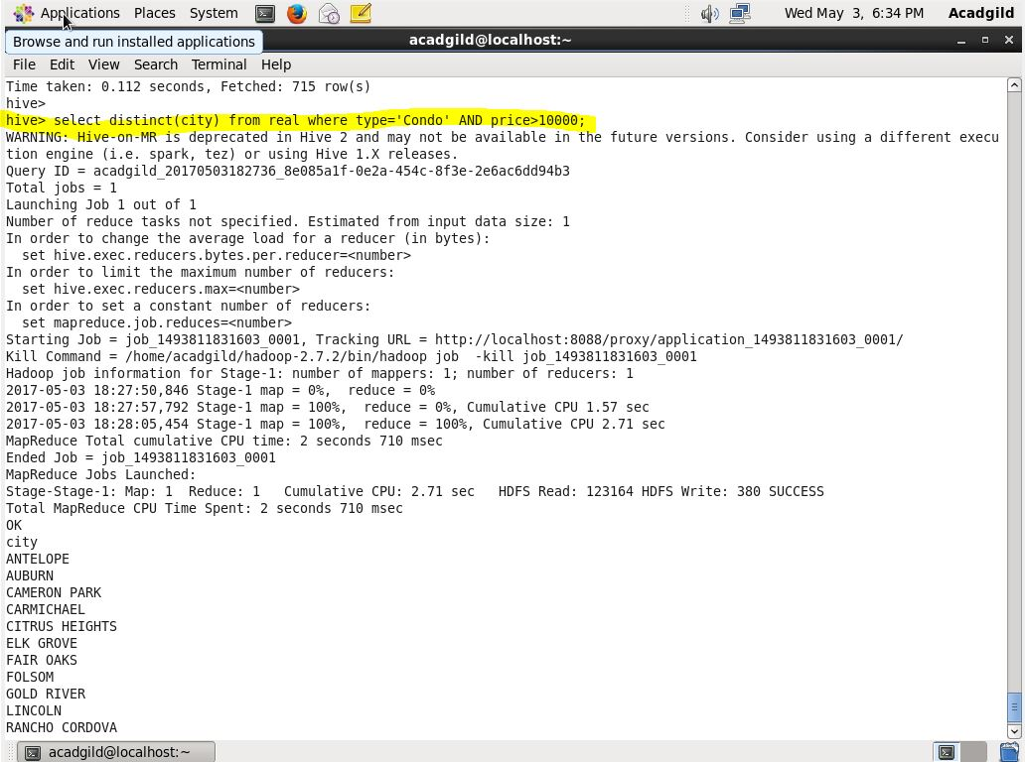

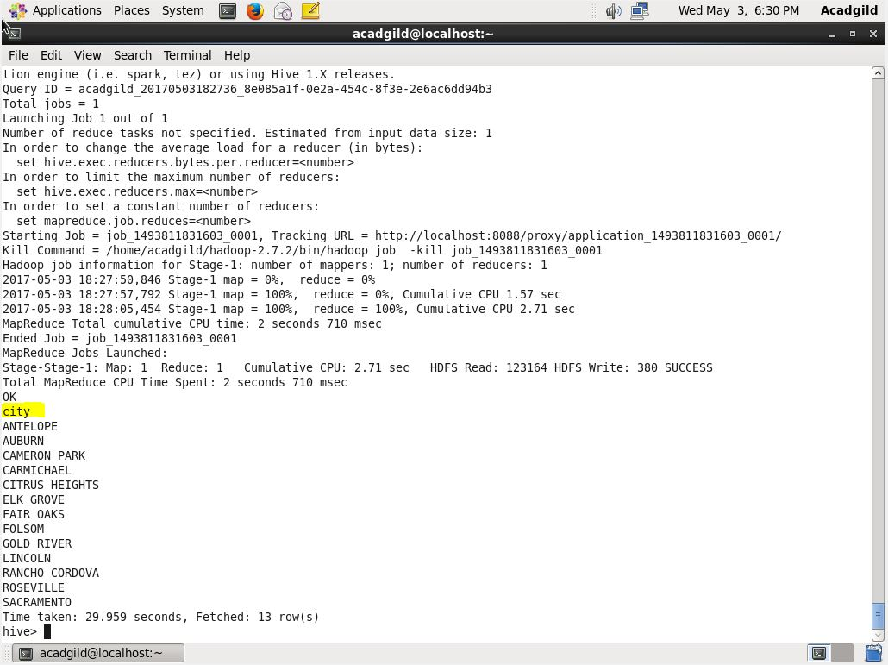

2. Write a hive query to find which is the cheapest Condo in CA. name the city,street and price for the Condo.

To get the cheapest condo in CA we filtered using where clause to get the condos of ca then we ordered it in the ascending order with price. Then limited to 1 to get the only cheapest condo in CA.

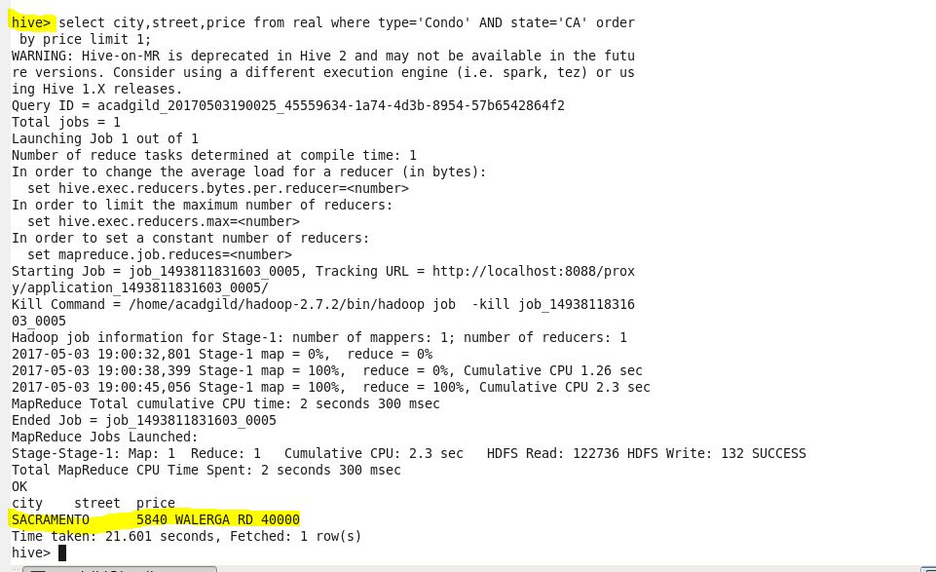

3. Write a hive query to list top 5 residency details which lie in the budget of 60000-120000, an area more than 1450, sold after 17th may, min bedroom 3 and,min bathroom 2.

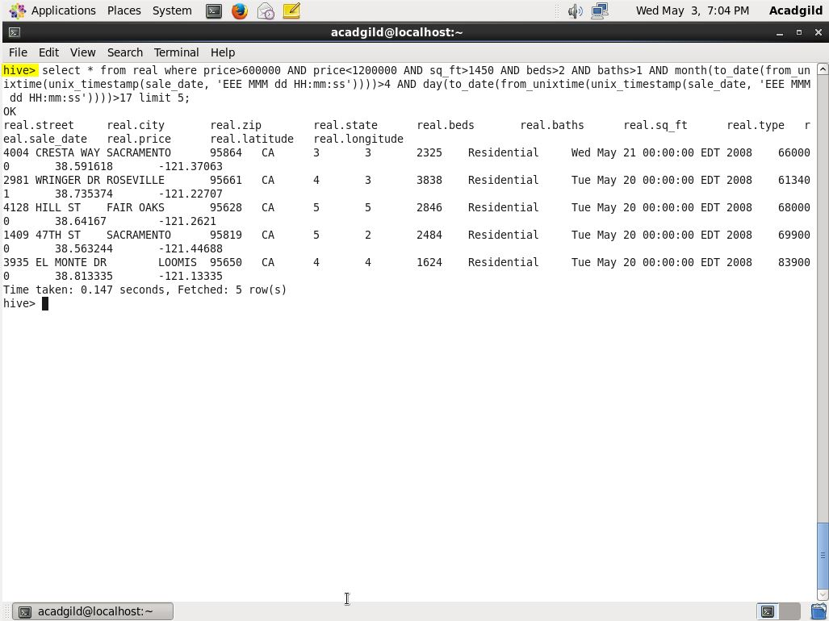

4. Write a hive query to separate list of residential apartments with more than 2 beds. Also include columns in following order City,Baths,Sq_feet,Price,flat_type,Beds respectively

